**END OF YEAR ASSESSMENT**

**SENIOR TWO**

**ENTREPRENEURSHIP**

**TIME: 2 HRS**

**INSTRUCTIONS; ATTEMPT ALL QUESTIONS**

**SECTION A (20 MARKS)**

1. A group of youths in Moroto District are planning to supply stationery to the District Local Government, but they are required to register as a private limited company. Advise them on any four documents involved in the formation of a company. (04 marks)
2. Regina dropped out of school in s.3 due to early pregnancy. She worked as a cleaner in a saloon and accumulated money for three years. With her little savings, she decided to rear local chickens and is now managing her poultry business alone.
3. Describe the form of business ownership Regina is operating. (02 marks)
4. Outline the advantages of such business ownership. (05 marks)
5. Your friend in s.1 needs help to get to know about the following organizations in full. Help her with the assignment as follows (04 marks)
6. URSB
7. TIN
8. SACCO
9. NSSF
10. You want to start a carpentry workshop in your area, list five factors you will consider when selecting machinery and equipment for your project. (05 marks)

**SECTION B (30 MARKS)**

1. Many fashion magazines invite people to transform people in a makeover. In a makeover, stylists and makeup artists transform a person. This is published in an article where it includes the old looks and the new looks of the person. As an entrepreneurship student,
2. Advise a person who wants a makeover on the methods that he/she should take note in order to avoid from being exploited by the makeup artiste. (10 marks)
3. Look around your community, how can you give it a makeover? (10 marks)
4. Business people always carry out advertising to inform the public about their products. It helps them attract more customers and create a brand image to the general public. As an entrepreneurship student, identify, name and explain the method of advertisement in each figure bellows. (10 marks)

a) b)

 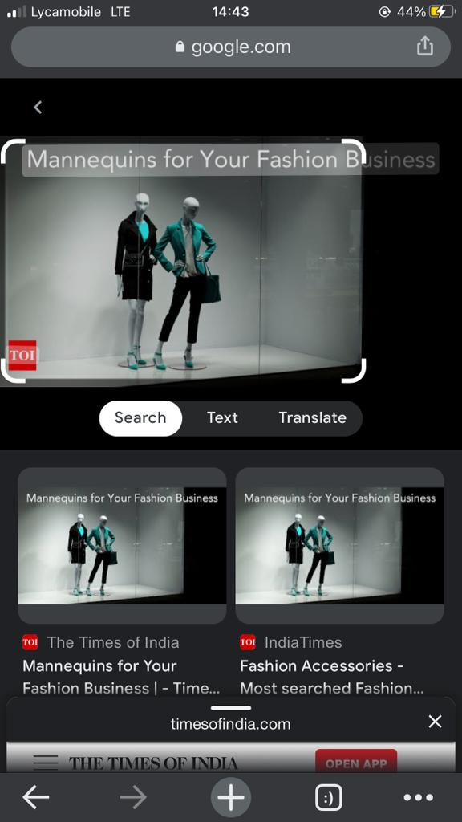

c) d)

 

e) f)

 

g)

